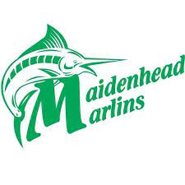
Club Records

Maidenhead Marlins Club Records Criteria
- Club records must be swum at a licensed Swim England or Official FINA meet
- Club records must be swum in a 25m (short course) or a 50m (long course) pool.
- There are 2 types of club records:
  - Age group and Senior Club records
  - Open Member Club records
- Age group and senior records are achieved when an active member is either representing the club, county or region whilst being registered at the club.
- Open member records are achieved when a fully registered or dual registered member is either representing Maidenhead Marlins, Berks & South Bucks, South East Region, Swim England, Team GB or another Selected international Team.

Age Group and Senior club records rules and Conditions
- Records must be swum as either Open/Male or female.
- Separate records for short course and long course records.
- Age group records are determined as:
  - 10/u years old
  - 11 years old
  - 12 years old
  - 13 years old
  - 14 years old
  - 15 years old
  - 16 years old
  - 17 years old
  - 18 years old
  - Open age
- Age groups mean age on day at midnight of record achieved.
- Open age is all ages

Open Records rules and Conditions
- Records must be swum as either Open/Male or Female.
- Separate records for short course and long course.
- Records can be set without age restrictions.
- Records must be set at a licensed Swim England or Official FINA meet.

How to claim a club record if it is not updated by MASC
- Check the existing club record in the event the claimant has achieved.
- Claimants must fully complete THIS FORM. Claims made by any other communication may not be considered.
- Where the claim does not satisfy one or more of the criteria, the claim shall be declined.
- Once a claim has been received and validated. The club records document published on the club website will be updated.

