This meet is affiliated to Swim England South East Region and will be held under Swim England laws and Swim England technical rules together with the conditions and rules described in this document (“Conditions”).
This event is aimed at Club Swimmers in accordance with Swim England Open Meet Licensing Guidelines Level 3 and Swim England safe competition Guidelines.

Age Groups / Competing Categories
- Age groups are: 9, 10, 11, 12, 13, 14 and 15+
- Age at Midnight 05th October 2025
- Swimmers must be 9 years of age (or older) on 05th October 2025.
- Swimmers must be or have applied to be registered with Swim England and may only enter events in their own age group.
- In accordance with Swim England’s Transgender and Non-Binary Competition Policy swimmers must enter either Male/Open or Female category
- The Female category is for birth sex females in accordance with Swim England’s Transgender and Non-Binary Competition Policy. By entering the ‘Female’ category, a swimmer confirms that their birth sex is female.

Events
- Heats will be run with all ages seeded together based on entry times and the slowest swimmers first.
- The promoter reserves the right to amend the Programme of Events to ensure the smooth running of the meet.
- It is the responsibility of the individual to report to the stewarding area in sufficient time for each event.
- The Promoters will not be held responsible for a swimmer missing the start of their heat.
- Starts will be “over the top” where possible, at the Referee’s discretion, to ensure that the events run to time in each session.

Awards
- All events will be ‘heat declared winner’. Awards will be made to the top three placed swimmers in each age group as per point 1 above.
- Presentations will not be made. Awards should be collected from the awards table.

Entries
- Entries will open at 11am 18-July-25.
- The Closing Date for entries 30-Aug-25. Entries will be accepted on a first-come-first served basis. The promoter reserves the right to bring forward the closing date once the maximum number of entries is reached.
- All swimmers will be placed into heats based on their submitted entry times, slowest to fastest.
- Entries must include date of birth and Swim England registration number details. The names and club for each swimmer must be the same as those registered with Swim England.
- Club entries must be made in an electronic format using the Hytek Team Manager entry software. The entry file set will be available for download via http://www.maidenheadmarlins.com. TeamUnify .sd3 files will also be accepted. Manual entries will not be accepted.
- Individual entries will be accepted for individuals only if made in an electronic format using the Hytek Team Manager entry software. The entry file set will be available for download via http://www.maidenheadmarlins.com. TeamUnify .sd3 files will also be accepted. Only 1 entry file will be accepted from any club.
- Clubs are responsible for ensuring adequate provision for supervision of their swimmers is made in line with up-to-date Safe Supervision Policy of Swim England.
- All clubs must return a fully completed signed Summary Entry Form by email. Entries will only be entered into our systems and processed once a fully completed signed Summary Entry Form and any fees due have been received and cleared.
- Correct payment for entry fees and coach/TM passes should be paid by direct bank transfer (please use your club’s name as a reference so that we can identify your payment).
- Bank transfers should be made the following account:
Account Name : Maidenhead Amateur Swimming Club
Account No : 49327143
Sort code : 60 – 13 – 35
Reference : [Your club name]
- The Promoter reserves the right to restrict entries to meet allocated pool time or on health and safety grounds.
- Any entry not accepted will be refunded in full; withdrawals will be refunded on presentation of valid medical evidence. Funds for any entries not accepted will be refunded by bank transfer shortly after notification of rejection.
- Entries must be received before the Closing Dates. Details of accepted entries will be posted on the Maidenhead ASC website and circulated to attending clubs as soon as possible after closing.
- Time trials will be accepted at the discretion of the Meet promoter and Referee. If time trials are accepted swimmers will be eligible for awards.
- The submission of entries will indicate acceptance of these Conditions.
- Withdrawals due to Certified Medical Reasons will be refunded by Maidenhead Marlins Swimming Club shortly after the meet has been completed.

Charges
Entry Fees: £ 8.50 per event (to include the regional levy per event)

Spectator Entry: £ 6.00 per adult. Children & OAP free. Payment by card at the entry desk please.
Spectators may be requested to follow certain precautions for the benefit of all swimmers, volunteers, officials and fellow spectators.

Coach Passes: £20.00 (weekend) or £10.00 (Day Pass) to include refreshments and a car park pass. Passes will be issued to Qualified Swimming coaches & Team Managers with up-to-date certification.

Officials
- Without sufficient licensed Swim England officials, we will not be able to run this meet. We would really appreciate all clubs sending swimmers to provide names and contact details of as many willing officials as possible on the entry form. Thank you.

Facilities
- This gala will take place at The Braywick Leisure Centre, Braywick Road, Maidenhead SL6 1BN (“Braywick”) which offers a ten lane 25m pool with anti-wave lane ropes, automated officiating equipment.
- Pay & Display parking is available at Braywick. Parking is free on Sundays.
- A secondary strobe light will be available.
- Backstroke ledges will not be available.

Warm Up
- The pool will be available for warm up at the start of each session. Timings will be as indicated in the Schedule of Events and the Programme.
- Swimmers should swim in the prescribed direction during free swimming and follow the one-way system once sprint lanes are opened.
- Warm up marshals will be appointed, it is the coach’s responsibility to supervise their swimmers during this period so as not to endanger themselves or others whilst in the water.
- Diving is not permitted during warm up except in designated sprint lanes as advised by the warm up marshals.
- A training pool will also be available throughout the day for supervised swim down/warm up.

General
- For safety and comfort reasons, we request that all swimmers place their swimming bags in the lockers provided. The lockers require a small padlock to be brought with the swimmer. Strict policy large bags are not allowed on the poolside.
- The changing rooms are unisex and will be patrolled during the Meet to ensure the safety of all the swimmers. It should also be noted that Braywick has security cameras in operation in this area. Only swimmers, officials, chaperones (Team Managers) and coaches with passes will be allowed into the changing area or poolside.
- In Line with Swim England guidance the use of Mobile phones is strictly prohibited in the changing village.
- Possessions and articles must not be left unattended as neither the Promoters nor Braywick Leisure Centre will accept any liability for any loss or damage that may occur during the meet.
- Swimmers must wear suitable clothing and footwear on the poolside. No wet clothing is allowed in the spectator seating area.
- Any conditions not covered in the competition rules will be dealt with in accordance with the laws of the sport and at the discretion of the Promoter. By submitting an entry, participants agree to be bound by any decisions made by the Promoter.

Health and Safety
- All participants must observe the safety precautions in operation at the Braywick Leisure Centre.
- To ensure the pool side is clutter free and for the comfort of swimmers and official’s Large bags are strictly prohibited on the poolside. Storage is available in the lockers in the changing village.
- Swimmers and coaches must ensure that they take no action that could potentially endanger themselves or others.
- Supervision and behaviour of the swimmers is always the responsibility of their swimming clubs.
- Prior to leaving the pool area, swimmers must dry off and put on appropriate clothing and footwear.
- It is the responsibility of competitors, coaches, and clubs to ensure that all swimmers are competent to the standard of the Swim England Competitive Start Award. Competitors may start from the side or in the water.

Data Protection
- Entries for this meet will be held and processed on a computer. By submitting entries, consent is deemed to have been given, as required by current legislation, to the holding and processing of personal information on a computer for the purposes of this event. It will then be subsequently deleted. Personal data, including submitted and recorded times, will be publicly available and accessible via the Internet before and after the meet.

Contact Details
- The meet is promoted by Maidenhead Amateur Swimming club
- For any information regarding the meet please see http://www.maidenheadmarlins.com in the first instance (select the Maidenhead Meets tab).
- For queries and submission of electronic entry files please email openmeets@maidenheadmarlins.com.
- Upper and lower qualifying times apply for this meet. See Entry Standards below.

Registration
There will be no signing in. Once an entry has been accepted, a competitor shall swim or give notice of withdrawal. Notice of withdrawals from a club should be declared to the Recorders advertised start time of the warm up for each session.

SCHEDULE OF EVENTS
Schedule of Events
Session 1 | Session 2
Saturday 04th October 2025 | Saturday 04th October 2025
Warm Up: 12:00 TBC | Warm Up: 16:15 TBC
Start Time: 13:00 TBC | Start Time: 17:15 TBC
Estimated Finish Time: TBC | Estimated Finish Time: TBC
101. Open/Male 400 Freestyle | 201. Female 400m Ind Medley
102. Female 200m Ind Medley | 202. Open/Male 200m Freestyle
103. Open/Male 100m Breaststroke | 203. Female 100m Butterfly
104. Female 50m Butterfly | 204. Open/Male 50m Backstroke
105. Open/Male 100m Freestyle | 205. Female 100m Backstroke
106. Female 200m Backstroke | 206. Open/Male 200m Breaststroke
107. Open/Male 200m Butterfly | 207. Female 50m Freestyle
108. Female 50m Breastroke | 208. Open/Male 100m Ind Medley
Session 3 | Session 4
Sunday 05th October 2025 | Sunday 05th October 2025
Warm Up: 10:30 TBC | Warm Up: 14:45 TBC
Start Time: 11:30 TBC | Start Time: 15:45 TBC
Estimated Finish Time: TBC | Estimated Finish Time: TBC
301. Female 400 Freestyle | 401. Open/Male 400m Ind Medley
302. Open/Male 200m Ind Medley | 402. Female 200m Freestyle
303. Female 100m Breastroke | 403. Open/Male 100m Butterfly
304. Open/Male 50m Butterfly | 404. Female 50m Backstroke
305. Female 100m Freestyle | 405. Open/Male 100m Backstroke
306. Open/Male 200m Backstroke | 406. Female 200m Breaststroke
307. Female 200m Butterfly | 407. Open/Male 50m Freestyle
308. Open/Male 50m Breastroke | 408. Female 100m Ind Medley

Qualifying Standards
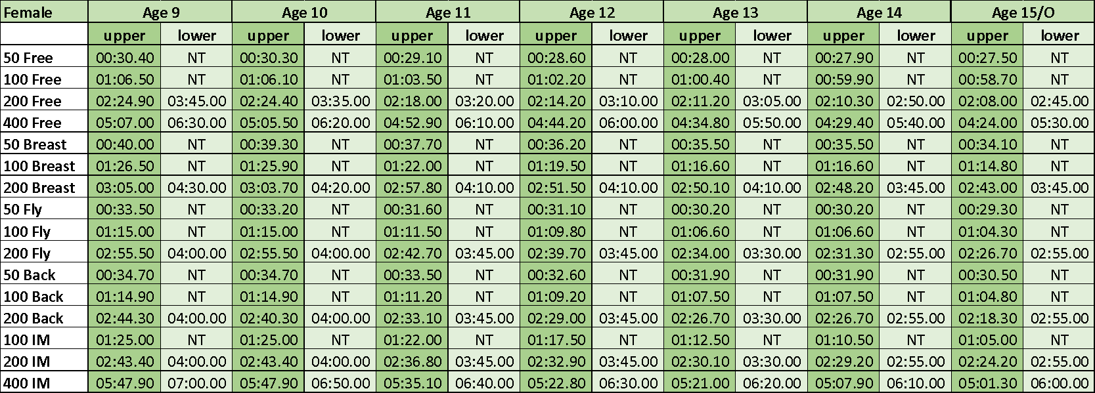
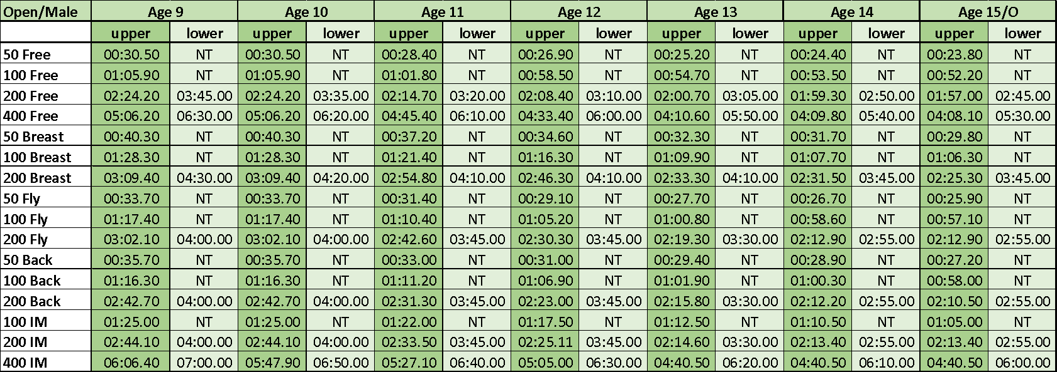

Summary Entry Form
CLUB
CONTACT Name
CONTACT ADDRESS
EMAIL
TELEPHONE NUMBER
Total number of swimmer entries
Total cost of swimmer entries
Number of coach passes
Total cost of coach passes
Total value of BACS transfer
(Please make BACS transfer to Maidenhead ASC)

